17-18 Sep Planet Honda Vinduro, Lot 64 Beard Road, Culham (Toodyay)

Directions: Thanks to Rod from Planet Honda for allowing us to use his property
Address where event will be located: Lot 64 Beard Road, Culham (Toodyay). How to get there from Perth:
Travel to Toodyay via Toodyay Road, head north through Toodyay (up the main street) over the Avon River towards Bolgart (Bindi Bindi-Toodyay Road);
Approx 18kms from Toodyay, turn Left onto Telegraph road, after 300m turn Left into Rockdale road
After 6kms Turn Right into Beard road, we will have some signs out on the day at Telegraph Road turn off also look for club arrows, Black arrows, orange background.
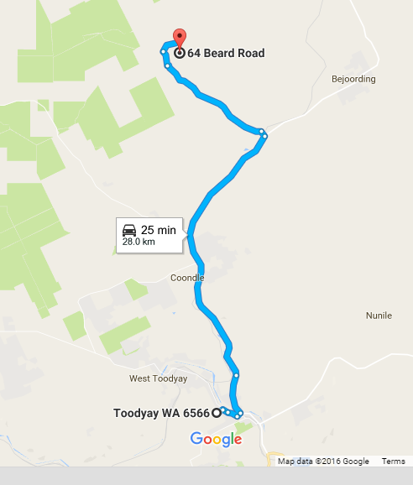
Sequence of Events

Event:
Clerk of the Course: Barry Mitcheson
Race Secretary: John Johnson
Scrutineers: Paul Barker
The only people allowed on the loop before 1.30pm Saturday are the designated track markers and officials.
Remember all bikes must be pre 1990, they do not have to be licenced as we run on private properties.

Saturday:
Sign on from 12 midday riding from 1.30pm. You can sign on any time after the aforementioned times. All bikes will be scrutineered for safety. Riders must wear correct safety gear. Riders brief at 1.00pm. Safety brief will to be given to all riders who turn up at other times. All bikes must be pre1990, the only modern bikes that will be used by designated personnel for safety reasons only. We do not wish to offend by having to tell someone their bike is ineligible. Please check if you have any doubts.
Sunday:
As this is a non-competitive ride, you can arrive at any time after the start time and sign on, be briefed and have your bike scrutineered prior to entering the loop. All riders taking part in this event must be members of VinduroWA, paid the entry fee and either holder of a current MA licence or take out a one event licence. Event entry is $30.00 plus non-competitive licence ($25.00) if required, one day membership ($15) avail. Free event membership offered to financial members of either ClassicMXWA or VMXWA. Sunday we will be testing our timing system as we are looking at different ways of timing our event, hopefully this will be successful
You can ride Saturday or Sunday or both days, it is your decision, for the one price
Saturday: The loop will be open from 1.30pm, last rider out at 4.30pm. All riders musted be signed out and in, to ensure all riders are accounted for.
Sunday: The loop will be opened from 9am until last rider out 2.30pm. All riders must be signed out and in to ensure all riders are accounted for. Remember you are all needed to help clean up
IN case of Injury:
First response by qualified club first aiders, ensure you sign on
Ambulance: Toodyay phone 000.
Please bring a sense of humour, this is supposed to be fun. Remember constructive criticism!

Camping is allowed Saturday night, toilets only. Bring own water, no dogs. Please ensure you drink responsibly.

