6-7 Aug 2016 Motorplex Mayhem Competition Major Sponsor Motorcycle Pitstop

Location
Approximately 2:30 hour south of Perth, two ways in to the Motorplex from Collie. As shown on the Map below travel either via Preston Rd or follow the main rd east out of Collie and Turn right down Piavanini Rd past the Collie MX club. Follow the signs to the Motorplex.

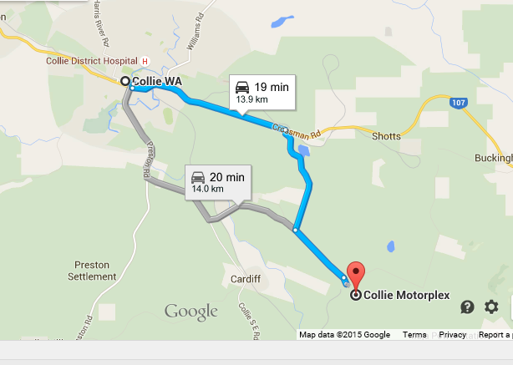

Drive past the Motorplex entrance and look for the VinduroWA signs at the next large bitumen turn off to the right. Travel up through the boom gate and large tyres, continue, you will come upon a large triangle intersection. Turn left and follow to the end veering around to the left at the bottom of the hill.

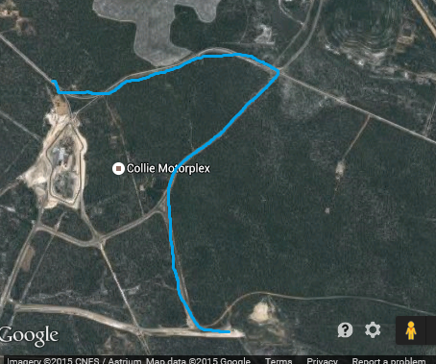

Camping is available at the site. There will be porta Loos. Bring your own Water. Camping is free. If anyone has a BBQ they can bring would be appreciated. A campfire(bonfire) will only be lit in one designated area. Please ensure you keep your area clean
There will be no riding area for children. So do not bring their bikes
Please ensure that when you leave your area it is clean, please respect the property

Event:
Proposed officials.
Steward/Clerk of Course: Barry Mitcheson.
Race Secretary: Kevin Shaw,
Scrutineers: TBA
Travelling Marshalls: Steve Melvin Toby Harrold
The only people allowed on the loop on Saturday are the designated track markers and officials.

Sign on and scrutineering from 8am Sunday. All bikes will be scrutineered for safety. Riders must wear correct safety gear. Riders brief 8.45am(Sun). All bikes must be pre1990, the only modern bikes that will be used by designated personnel for safety reasons only. We do not wish to offend by having to tell someone their bike is ineligible. Please check if you have any doubts.

Entry available on the day

Club Members
You must be a Full Member of the club to ride in this event. Memberships can be obtained on the day. You must be signed on and had your bike and equipment scrutineered before the commencement of the event. All riders taking part in this event must be members of VinduroWA, paid the entry fee, be holder of a current MA licence or take out a one event licence. Event entry is $30.00 plus one event competitive licence ($60.00) if required, full membership $70.00.
Event Sequence
Saturday: No Riding only officials and track markers
Sunday: The event will commence at 9am and finish at 2.30pmor when the last rider has completed the required loops. A detailed sequence of events and scoring is on the website.
IN case of Injury:
First response by qualified club first aiders, ensure you sign on
Hospital: Collie Hospital 9735 1333
Ambulance: Collie, phone 000 or 9791 4999
Please bring a sense of humour, this is supposed to be fun. Remember constructive criticism!
Sponsors:
Motorcycle Pitstop
G F McKay Electrics
MX Retread
Southwest Digital

