28-29 May 1437 Lower Hotham Rd, Boddington
Come Try 29 May Sponsored by Nautilus Productions
Directions: turn off the Albany Highway and follow the rd through the Boddington Townsite. Once passed the townsite follow Rd for approx. 10km and turn left onto the Lower Hotham Rd follow for approx. 14km and turn left into the farm, follow track to event. Look out for VinduroWA signs. You might also see some old T&E signs.
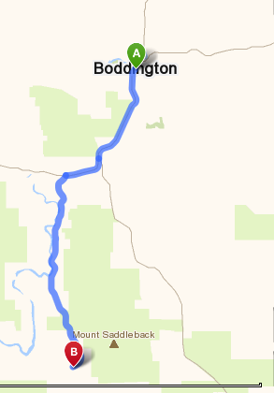
Sequence of Events

Event:
Clerk of the Course: Barry Mitcheson and Nick Maxfield
Race Secretary: Kevin Shaw, John Johnson
Scrutineers: Neil Stevens
The only people allowed on the loop before 1.30pm Saturday are the designated track markers and officials.
Remember all bikes must be pre 1990, they do not have to be licenced as we run on private properties.

Saturday: Members only, including one event membership holders.

Sign on from 12 midday riding from 1.30pm. You can sign on any time after the aforementioned times. All bikes will be scrutineered for safety. Riders must wear correct safety gear. Riders brief at 1.00pm. Safety brief will to be given to all riders who turn up at other times. All bikes must be pre1990, the only modern bikes that will be used by designated personnel for safety reasons only. We do not wish to offend by having to tell someone their bike is ineligible. Please check if you have any doubts.
Sunday, sponsored by Nautilus productions, spot prizes, members and Come Triers
Go-Moto(Come Triers) entrants
Riders who have NEVER been issued a licence, NEVER ridden any other Motorcycling Western Australia permitted events including GoMoto, any practice or any competition may be issued a FREE Come and Try licence. This is a one-time free licence for riders to give organised sport a try. You do not have to be a club member. This is a one off event. So get your backside trackside!!!. All you need is a pre1990 bike. Entry fee $30.00
Club members bring a mate down let them do something ridiculous and share your bike.
Club Members
As this is a non-competitive ride, you can arrive at any time after the start time and sign on, be briefed and have your bike scrutineered prior to entering the loop. All riders taking part in this event must be members of VinduroWA, paid the entry fee and either holder of a current MA licence or take out a one event licence. Event entry is $30.00 plus non-competitive licence ($25.00) if required, one day membership ($15) avail, full membership $70.00.
You can ride Saturday or Sunday or both days, it is your decision, for the one price
Saturday: The loop will be open from 1.30pm, last rider out at 4.30pm. All riders musted be signed out and in, to ensure all riders are accounted for.
Sunday: The loop will be opened from 9am until last rider out 2.30pm. All riders must be signed out and in to ensure all riders are accounted for.
IN case of Injury:
First response by qualified club first aiders, ensure you sign on
Hospital: Boddington Health Services: 9883 4444 53 - 61 Hotham Avenue, Boddington
Ambulance: Boddington, phone 000 or 9621 1613
Please bring a sense of humour, this is supposed to be fun. Remember constructive criticism!

Camping is allowed Saturday night, toilets only. Bring own water, no dogs. Please ensure you drink responsibly.

