30 April – 01 May 2016 Yorkrakine Vinduro sponsored by Nautilus Productions
The VinduroWA club are proud to present a Vintage Enduro, non- competitive event for all pre 1990 bikes for 2016, at 2755 North Bungulla Rd, Yorkrakine. Sponsored by Nautilus Productions.
Travel east along Gt Eastern Highway through Tammin, travel approx. 12.8kms to the Bungulla North Rd turn off. Turn left, follow for approx. 27.5 to 2755 Bungulla North RD (that’s correct as per the resident Ray) turn left just after the hall, follow track to MX area. Vinduro signs from GEH.
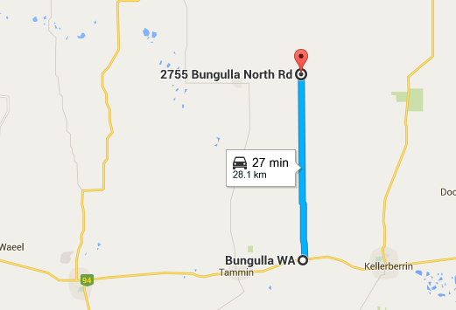

Camping
Camping is available at the site, I should be there Friday night as I will be following up on Ray’s marking in the morning, assistance needed. There are toilets and shower, there is a BBQ . Bring your own Water.
There will be an area for kids to ride but they must be supervised at all times, they will not be allowed on the MX or vinduro track, please do not let them ride in these areas. I repeat they must be supervised, no supervision, no ride
Please ensure that when you leave your area it is clean, please respect Ray Reids property property.

Event Details
Clerk of the Course: Barry Mitcheson
Position
Track Master | Barry Mitcheson
assist | Chris Wright
Event Clerk of Course | Barry Mitcheson
Race Secretary
Sign on assist
Scrutineer
First Aid
First Aid
Sweep
Sweep
Clean Up
assist
assist
assist
assist
As you can see, volunteers needed to assist. If you can help please don’t just wait for it all to be done for you, get involved.
The only people allowed on the loop before 12.30pm are the designated track markers and officials.
Sign on from 11.00am Saturday and 8am Sunday. All bikes will be scrutineered for safety. Riders must wear correct safety gear. Riders brief at 12.00pm(Sat) and 8am(Sun). All bikes must be pre1990, the only modern bikes that will be used by designated personnel for safety reasons only. We do not wish to offend by having to tell someone their bike is ineligible. Please check if you have any doubts.
Trials bikes, got a pre-1990 trials bike bring it down and we’ll set up some sections for you to practice on.
As this is a non-competitive ride, you can arrive at any time after the start time and sign on, be briefed and have your bike scrutineered prior to entering the loop. All riders taking part in this event must be members of VinduroWA,. Event entry is $35.00 ($30.00 per rider charge for venue usage, $5.00 club fee) plus non-competitive licence ($25.00) if required, one day membership ($15) avail, full membership $70.00.
You can ride Saturday or Sunday or both days, it is your decision, for the one price.
Saturday: The loop will be open from 12.30pm, last rider out at 4.30pm. All riders musted be signed out and in, to ensure all riders are accounted for.
Sunday: The loop will be opened from 9am until last rider out 2.30pm. All riders must be signed out and in to ensure all riders are accounted for. A variety of spot prizes will be given out on Sunday thanks to our sponsor Nautilus Productions, please support Pat and Rozz details to be placed on the website soon

In case of Injury
First response by qualified club first aiders, ensure you sign on
Hospital: Kelleberrin Hospital 9045 6222
Ambulance: Kelleberin, phone 000 or 9621 1613
Ray Reid 9638 1072 and 0418941850

Saturday Night
BBQ will be lit. Will hold a club meeting at the venue

Sunday
There will have a small presentation of a variety of differing prizes for some stupid things. Please hang around for presentation and assist in the clean-up. The response to the clean-up at Jindong, meant all signage was collected within 30 minutes, thank you
Please bring a sense of humour, this is supposed to be fun. This is your club, please make any criticism constructive. Have a great weekend!

