19 – 20 September 1437 Lower Hotham Rd, Boddington
Directions: turn off the Albany Highway and follow the rd through the Boddington Townsite. Once passed the townsite follow Rd for approx. 10km and turn left onto the Lower Hotham Rd follow for approx. 14km and turn left into the farm, follow track to event. Look out for VinduroWA signs. You might also see some old T&E signs.
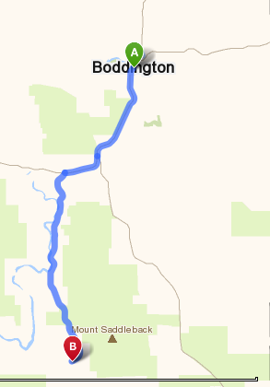
Sequence of Events

Saturday: Just marking the loop any assistance appreciated. From 12 midday.

Sunday: Sign on 08.30am, riding from 9am.

Cost: $30.00, one event licence (if required) $15.00, one day membership $15.00

Camping ids allowed, but no facilities. Bring own water, no dogs

