8-9 Aug Mud Farm Vinduro
The VinduroWA club is proud to present a Vintage Enduro, non- competitive event for all pre 1990 bikes, at Evans Rd, Chapman Hill, WA. This is on a working farm and unused for this type of event, the loop should be fast , flowing and mud holes, plenty of fun for all
Travelling south on Busselton bypass turn left onto Queen Elizabeth Ave, Vasse and follow it for approx. 9km at the bend in the Road where Payne Road starts, turn left onto Don Rd approx. 2 km, turn right at the T junction into Evan approx. 1.4km turn right at the sheds. Look out for VinduroWA road side signs

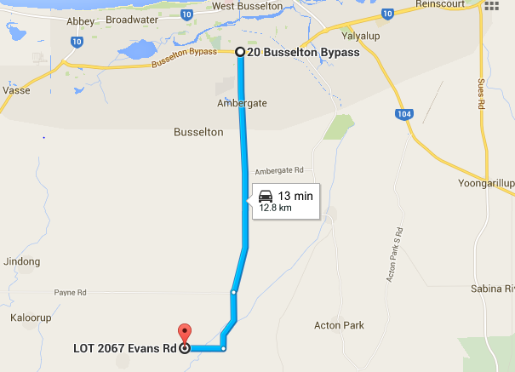

Camping is available at the site. There is a toilet and large shed. Bring your own Water. Camping is free. No dogs
There will be an area for kids to ride but they must be supervised at all times.
Please ensure that when you leave your area it is clean, please respect the property
Event:
Clerk of the Course: Barry Mitcheson and Nick Maxfield
The only people allowed on the loop before 1pm are the designated track markers and officials.
Sign on from 11.30am Saturday and 8am Sunday. All bikes will be scrutineered for safety. Riders must wear correct safety gear. Riders brief at 12.30pm(Sat) and 8am(Sun). All bikes must be pre1990, the only modern bikes that will be used by designated personnel for safety reasons only. We do not wish to offend by having to tell someone their bike is ineligible. Please check if you have any doubts.
As this is a non-competitive ride, you can arrive at any time after the start time and sign on, be briefed and have your bike scrutineered prior to entering the loop. All riders taking part in this event must be members of VinduroWA, paid the entry fee, be holder of a current MA licence or take out a one event licence. Event entry is $30.00 plus non-competitive licence ($25.00) if required, one day membership ($15) avail, full membership $60.00.
You can ride Saturday or Sunday or both days, it is your decision, for the one price
Saturday: The loop will be open from 1pm, last rider out at 4.30pm. All riders musted be signed out and in, to ensure all riders are accounted for.
Sunday: The loop will be opened from 9am until last rider out 2.30pm. All riders must be signed out and in to ensure all riders are accounted for.
IN case of Injury:
First response by qualified club first aiders, ensure you sign on
Hospital: Busselton Hospital 9754 0333
Ambulance: Busselton, phone 000 or 9752 3866
Saturday Night
We’ll have a look at another movie night if people would like or just bench racing around the fire.
Please bring a sense of humour, this is supposed to be fun. Please make any criticism constructive. Have a great weekend

