16-17 May Jaydale Farm, Hebb Rd Collie

Location
Approximately 2:45 hour south of Perth, will be sign posted at turn off
Jaydale Farm is located at RMB 569 Hebb Road, Collie, 20km east of Collie, then right onto Hebb Road for 6km. Turn left into J&L Jacksons. After the cattle grid veer left around the bush outcrop.

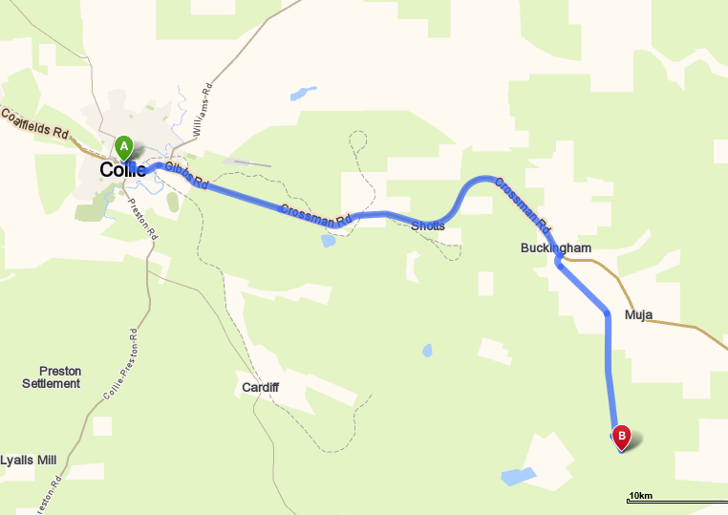

Camping is available at the site. There will be porta potties. Bring your own Water. Camping is free. If anyone has a BBQ they can bring would be appreciated. Doug Ullock is cooking a butt of beef and Beef and gravy rolls will be on sale for $3.00 money going to the club. A campfire(bonfire) will only be lit in one designated area. Please ensure you keep your area clean
There will be an area for kids to ride but they must be supervised at all times.
Please ensure that when you leave your area it is clean, please respect the property

Event:
Clerk of the Course: Barry Mitcheson and Nick Maxfield
Scrutineers: Craig Frost and Neil Stevens
The only people allowed on the loop before 1pm Saturday are the designated track markers and officials.

Sign on from 11.30am Saturday and 8am Sunday. You can sign on any time after the aforementioned times. All bikes will be scrutineered for safety. Riders must wear correct safety gear. Riders brief at 12.30pm(Sat) and 8am(Sun), safety brief to be given to all riders who turn up at other times. All bikes must be pre1990, the only modern bikes that will be used by designated personnel for safety reasons only. We do not wish to offend by having to tell someone their bike is ineligible. Please check if you have any doubts.

Go-Moto(Come Triers) entrants
Riders who have NEVER been issued a licence, NEVER ridden any other Motorcycling Western Australia permitted events including GoMoto, any practice or any competition may be issued a FREE Come and Try licence. This is a onetime free licence for riders to give organised sport a try. You do not have to be a club member. This is a one off event. So get your backside trackside!!! We will even set up a beginner’s loop where you can gain confidence in riding your bike (if required) before tackling the longer loop, or even just learn to ride. We will supply assistance from our club members.

Club Members
As this is a non-competitive ride, you can arrive at any time after the start time and sign on, be briefed and have your bike scrutineered prior to entering the loop. All riders taking part in this event must be members of VinduroWA, paid the entry fee, be holder of a current MA licence or take out a one event licence. Event entry is $30.00 plus non-competitive licence ($25.00) if required, one day membership ($15) avail, full membership $60.00.
You can ride Saturday or Sunday or both days, it is your decision, for the one price
Saturday: The loop will be open from 1pm, last rider out at 4.30pm. All riders musted be signed out and in, to ensure all riders are accounted for.
Sunday: The loop will be opened from 9am until last rider out 2.30pm. All riders must be signed out and in to ensure all riders are accounted for.
IN case of Injury:
First response by qualified club first aiders, ensure you sign on
Hospital: Collie Hospital 9735 1333
Ambulance: Collie, phone 000 or 9791 4999
Please bring a sense of humour, this is supposed to be fun. Remember constructive criticism!

