13-14 Jun Motorplex Mayhem Part 1

Location
Approximately 2:45 hour south of Perth, two ways in to the Motorplex from Collie. As shown on the Map below travel either via Preston Rd or follow the main rd east out of Collie and Turn right down Piavanini Rd past the Collie MX club. Follow the signs to the Motorplex.

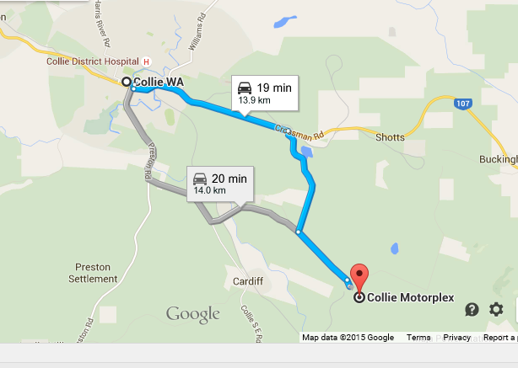

Drive past the Motorplex entrance and look for the VinduroWA sign(hopefully I’m there before you) at the next large bitumen turn off to the right. Travel up through the boom gate and large tyres, continue, you will come upon a large triangle intersection. Turn left and follow to the end veering around to the left at the bottom of the hill.

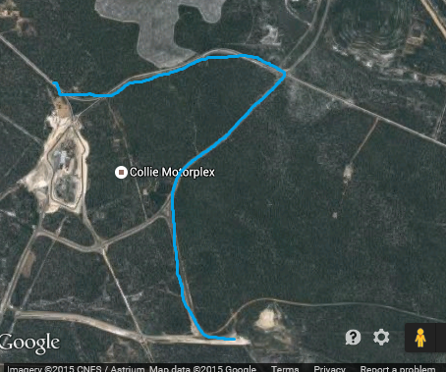

Camping is available at the site. There will be porta potties. Bring your own Water. Camping is $5.00 per person ( a levy placed on by the Motorplex management as part of our usage deal). If anyone has a BBQ they can bring would be appreciated. A campfire(bonfire) will only be lit in one designated area. Please ensure you keep your area clean
There will be an area for kids to ride but they must be supervised at all times.
Please ensure that when you leave your area it is clean, please respect the property

Event:
Clerk of the Course: Barry Mitcheson, Nick Maxfield and Steve Melvin(TBA)
Scrutineers: depending on availability, Craig Frost, Neil Stevens, John Johnson, Jeremy Butler and Dale James
The only people allowed on the loop before 1pm Saturday are the designated track markers and officials.

Sign on and scrutineering from 12pm Saturday and 8am Sunday. You can sign on any time after the aforementioned times. All bikes will be scrutineered for safety. Riders must wear correct safety gear. Riders brief at 12.30pm(Sat) and 8am(Sun), safety brief to be given to all riders who turn up at other times. All bikes must be pre1990, the only modern bikes that will be used by designated personnel for safety reasons only. We do not wish to offend by having to tell someone their bike is ineligible. Please check if you have any doubts.

Club Members
As this is a non-competitive ride, you can arrive at any time after the start time and sign on, be briefed and have your bike scrutineered prior to entering the loop. All riders taking part in this event must be members of VinduroWA, paid the entry fee, be holder of a current MA licence or take out a one event licence. Event entry is $30.00 plus non-competitive licence ($25.00) if required, one day membership ($15) avail, full membership $60.00.
You can ride Saturday or Sunday or both days, it is your decision, for the one price
Saturday: The loop will be open from 1pm, last rider out at 4.30pm. All riders musted be signed out and in, to ensure all riders are accounted for.
Sunday: The loop will be opened from 9am until last rider out 2.30pm. All riders must be signed out and in to ensure all riders are accounted for.
IN case of Injury:
First response by qualified club first aiders, ensure you sign on
Hospital: Collie Hospital 9735 1333
Ambulance: Collie, phone 000 or 9791 4999
Please bring a sense of humour, this is supposed to be fun. Remember constructive criticism!

